India Electricity Consumption
Analysis & Forecasting

Data Analyst Internship Project Report

Author: [Your Name]
Technology Stack: Python | Pandas | NumPy | Plotly | Streamlit | Statsmodels
Dataset Period: 2013 – 2024 | Project File: india_electricity_analysis.py

1. Executive Summary
This project delivers an end-to-end data analysis and forecasting solution for India's daily electricity consumption from 2013 to 2024. Drawing on a publicly available Kaggle dataset compiled from POSOCO records, the project applies a complete data analyst workflow: raw data ingestion and cleaning, exploratory analysis, entity-level profiling, IQR-based anomaly detection, Holt-Winters time-series forecasting, and an interactive Streamlit dashboard.
The cleaned dataset covers 3,707 daily records across 38 columns, spanning 34 geographic entities plus national totals. Key outputs include a validated 30-day forecast (MAPE 3.84% on a 90-day holdout), identification of 37 statistically unusual consumption days, and an interactive dashboard exposing all analysis layers. All project code resides in a single file: india_electricity_analysis.py.

2. Problem Statement
India's electricity grid serves a diverse geography through dozens of states, Union Territories, and distribution entities. Daily consumption records across these entities form a rich time series spanning over a decade of growth, seasonal variation, and structural change.
The analytical question addressed: How can historical daily electricity consumption data for India and its geographic entities be systematically cleaned, analysed, and modelled to reveal consumption patterns, identify statistically unusual observations, and generate a short-term national forecast?
The raw dataset contains missing calendar dates, sparse entity values, and floating-point precision artefacts. The project addresses each challenge through a documented cleaning pipeline before any analysis is performed.

3. Project Objectives
- Load and inspect the raw CSV dataset from Kaggle.
- Clean and prepare the data: parse dates, convert numeric types, recalculate missing totals, preserve entity-level NaN values without zero-filling.
- Reshape the wide-format dataset into a long-format tidy structure for entity-level analysis.
- Analyse national consumption trends at daily, monthly, and yearly granularity.
- Compare geographic entities by total and average consumption.
- Provide entity-specific yearly and monthly trend analysis.
- Detect statistically unusual consumption days using the IQR method at both national and entity levels.
- Build and validate a 30-day electricity consumption forecast using Holt-Winters Exponential Smoothing with a 90-day chronological holdout.
- Develop an interactive Streamlit dashboard with Plotly visualisations and sidebar entity/date filters.
- Present findings clearly for internship evaluation and as a Data Analyst portfolio piece.

4. Dataset Description
Dataset Name | India's Electricity Consumption Dataset
Platform | Kaggle
Dataset Author | Aryan Khurana (aryankhurana1701)
URL | https://www.kaggle.com/datasets/aryankhurana1701/state-wise-electricity-consumption-in-india
Underlying Source | POSOCO – Power System Operation Corporation of India
Raw Shape | 3,707 rows × 39 columns
Date Range | 2013-01-06 to 2024-09-29 (daily)
Partial Years | 2013*, 2023*, 2024* (* = incomplete calendar year)
Unit of Measure | MU (Million Units = GWh)
Missing Dates | 578 calendar dates absent (irregular series)

Geographic entities covered: Indian states, Union Territories (Chandigarh, Delhi, Daman & Diu, Dadra & Nagar Haveli, Puducherry), DVC (Damodar Valley Corporation), and Essar Steel. DVC and Essar Steel are excluded from the long-format geographic analysis since they are not state/UT entities.
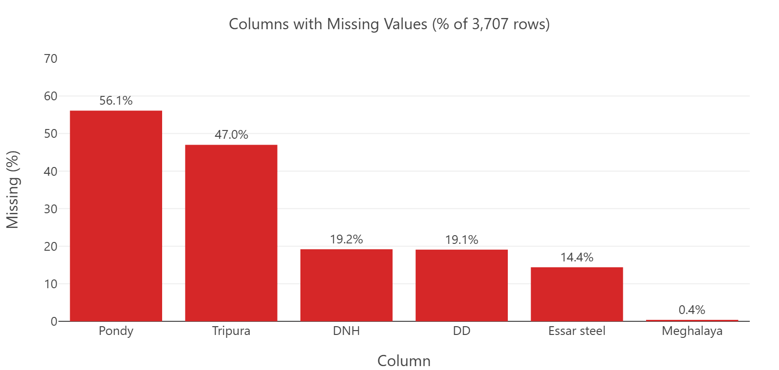
Figure 1 — Columns with Missing Values. Six columns have notable NaN rates; Pondy (56.1%) and Tripura (47.0%) are most affected. Missing values are preserved as NaN — not zero-filled.

5. Tools and Technologies
Library | Version | Role in Project
pandas | ≥1.5 | Data loading, cleaning, reshaping (wide-to-long melt), aggregation
numpy | ≥1.23 | Numerical operations, IQR fence calculations
plotly | ≥5.x | All interactive charts: line, bar, scatter, horizontal bar
streamlit | ≥1.25 | Web dashboard framework, KPI cards, widgets, session state
statsmodels | ≥0.14 | ExponentialSmoothing (Holt-Winters) for forecasting

All code resides in a single file — india_electricity_analysis.py (~1,500 lines). No additional Python modules or helper scripts are used.

6. Data Cleaning and Preprocessing
- Step 1 — CSV Loading — Loaded with pandas (index_col=0 absorbs the unnamed row-index column).
- Step 2 — Date Parsing — Dates column converted to datetime (errors='coerce'). All 3,707 parsed with zero NaT values.
- Step 3 — Chronological Sort — Rows sorted by date; integer index reset.
- Step 4 — Numeric Conversion — All 36 entity columns and Total Consumption converted to float64 (errors='coerce' → NaN on non-numeric).
- Step 5 — Total Recalculation — 6 missing Total Consumption values (April 2023) recalculated as row-wise sum of entity columns (skipna=True).
- Step 6 — Rounding — Total Consumption rounded to 2 decimal places to remove floating-point artefacts.
- Step 7 — NaN Preservation — Pondy, Tripura, DNH, DD, Essar Steel, Meghalaya NaN values intentionally kept. Zero-filling would be analytically incorrect.
- Step 8 — Long-Format Reshape — Wide DataFrame (3,707 × 38) melted into long format (126,038 × 3: Dates, State, Consumption). DVC and Essar Steel excluded.

Shape | Rows | Columns | Description
Cleaned (wide) | 3,707 | 38 | Dates + 36 entity columns + Total Consumption
Long-format | 126,038 | 3 | Dates | State | Consumption (34 entities × 3,707 dates)

Column | Missing Values | % of Rows | Action Taken
Pondy | 2,078 | 56.1% | Preserved as NaN
Tripura | 1,742 | 47.0% | Preserved as NaN
DNH | 712 | 19.2% | Preserved as NaN
DD | 707 | 19.1% | Preserved as NaN
Essar steel | 532 | 14.4% | Preserved as NaN
Meghalaya | 14 | 0.4% | Preserved as NaN

Duplicate rows: 0 | Duplicate dates: 0 | Missing calendar dates: 578

7. Exploratory Data Analysis
Four core visualisations were created to explore the dataset at national level. All charts use Plotly with interactive hover, zoom, and unified hover mode.
A. Daily Electricity Consumption Trend (2013–2024)
Line chart of national Total Consumption across the full date range. Natural gaps appear where calendar dates are absent. The chart is date-range filterable in the dashboard.
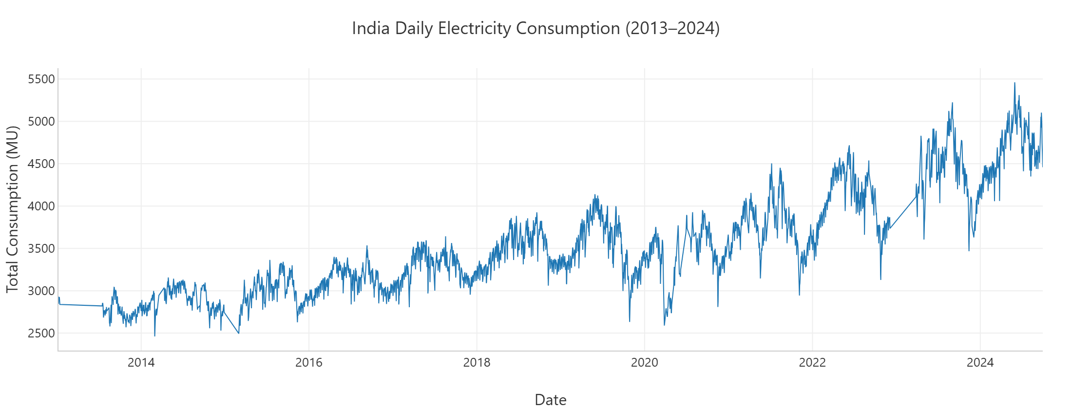
Figure 2 — India Daily Total Electricity Consumption (2013–2024). The long-term upward trend and seasonal oscillations are clearly visible.
B. Monthly Consumption Pattern
Bar chart of total consumption by calendar month (January–December), aggregated across all years. Reveals within-year seasonal demand patterns.
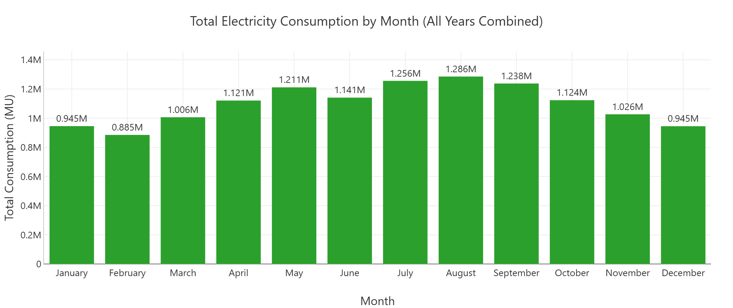
Figure 3 — Total Electricity Consumption by Month (All Years Combined). Higher consumption observed in summer (May–August) and winter (November–January) months.
C. Yearly Consumption Totals
Bar chart of total annual consumption. Partial years (2013*, 2023*, 2024*) are shown in lighter colour and annotated to avoid misleading year-on-year comparisons.
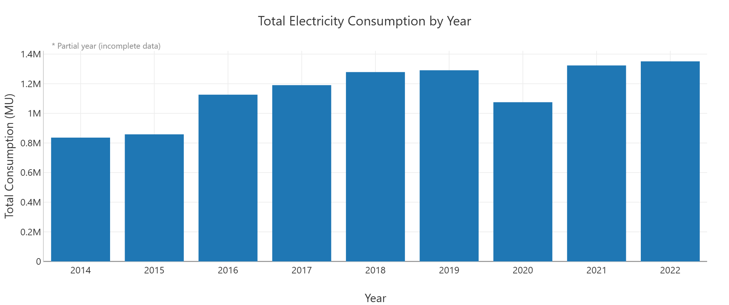
Figure 4 — Total Electricity Consumption by Year. Partial years (2013*, 2023*, 2024*) are shown in light blue. Complete years show a consistent growth trend.
D. Consumption by Geographic Entity
Horizontal bar chart ranking all 34 geographic entities by total recorded consumption. Sort order is determined dynamically at runtime from the actual data.
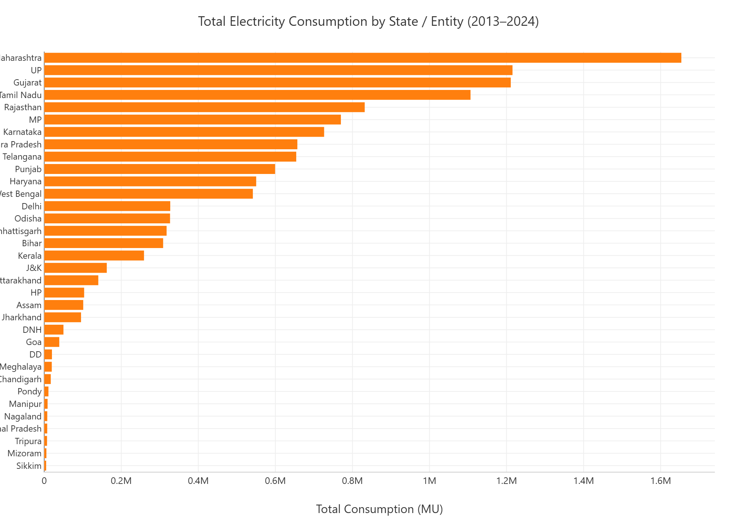
Figure 5 — Total Consumption by Geographic Entity (2013–2024). Maharashtra ranks highest; smaller UTs contribute least.

8. Key Descriptive Results / KPIs
National-level KPIs computed from the cleaned dataset (2013–2024):
Total National Consumption (2013–2024) | 13,185,119.20 MU
Average Daily Consumption | 3,556.82 MU
Peak Consumption Day | 5,460.70 MU — 2024-05-30
Lowest Consumption Day | 2,460.50 MU — 2014-03-01
Date Range | 2013-01-06 to 2024-09-29 (3,707 days)
Number of Columns (entities + total) | 38
Geographic Entities in Long Format | 34 (DVC and Essar Steel excluded)
Partial / Incomplete Years | 2013*, 2023*, 2024*

Yearly Consumption and Year-over-Year Growth
Year | Total Consumption (MU) | YoY Growth (%)
2013* | 424,021.4 | —
2014 | 835,961.8 | +97.15%
2015 | 858,142.6 | +2.65%
2016 | 1,126,228.3 | +31.24%
2017 | 1,190,508.6 | +5.71%
2018 | 1,278,982.2 | +7.43%
2019 | 1,291,201.5 | +0.96%
2020 | 1,075,208.5 | -16.73%
2021 | 1,323,615.8 | +23.10%
2022 | 1,351,058.5 | +2.07%
2023* | 1,181,767.7 | -12.53%
2024* | 1,248,422.3 | +5.64%

* Partial/incomplete calendar year — comparisons to full years should be made with caution.
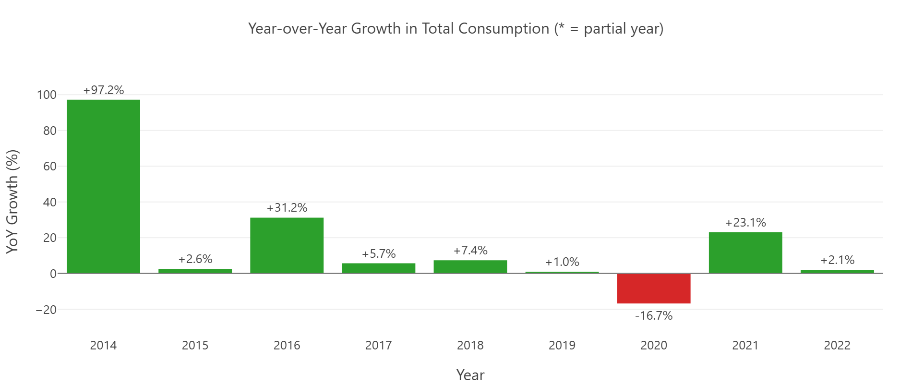
Figure 6 — Year-over-Year Growth in Total Consumption. 2020 shows a notable decline; 2021 shows a strong recovery. Partial years (marked *) are not directly comparable to full years.
Monthly Consumption Totals (All Years Combined)
Month | Total Consumption (MU)
January | 945,372.4
February | 885,177.9
March | 1,006,437.1
April | 1,120,924.5
May | 1,211,416.2
June | 1,141,216.5
July | 1,255,969.9
August | 1,285,618.6
September | 1,237,952.4
October | 1,123,518.7
November | 1,026,420.6
December | 945,094.4

9. Entity-Level Analysis
Entity-level analysis was performed on all 34 geographic entities after reshaping the dataset into long format (126,038 rows × 3 columns: Dates, State, Consumption). DVC (power utility) and Essar Steel (industrial consumer) were excluded as they are not geographic state/UT entities.
Functions used:
- calculate_state_kpis(long_df) — Per-entity KPIs: Total, Avg Daily, Max Day, Min Day
- calculate_top_entities(long_df, n) — Top-N entities by total consumption (ranked dynamically)
- calculate_entity_yearly_trend(long_df) — Yearly aggregated consumption for a single entity
- calculate_entity_monthly_trend(long_df) — Monthly seasonal profile for a single entity
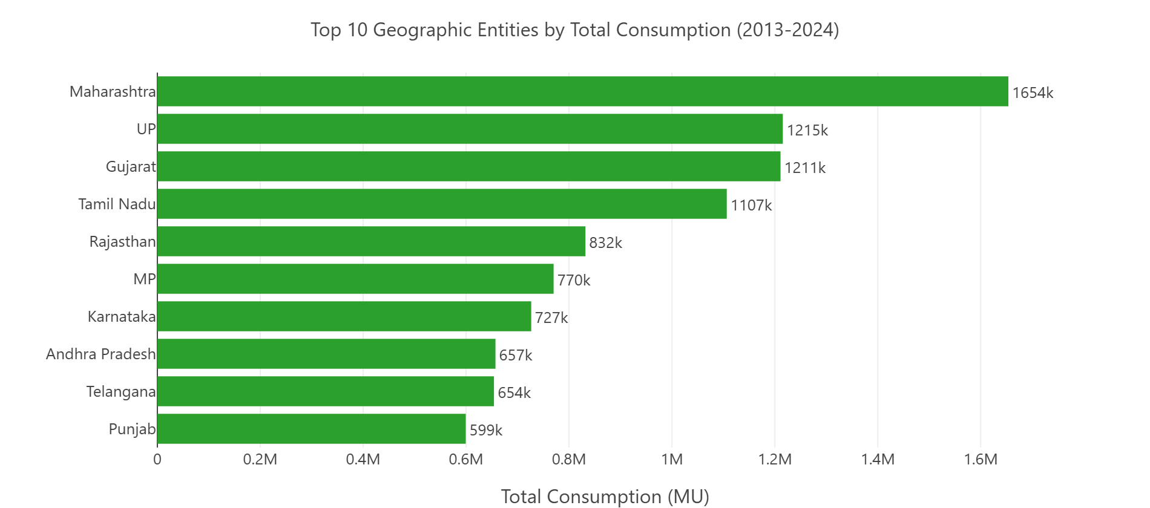
Figure 7 — Top 10 Geographic Entities by Total Consumption (2013–2024). Maharashtra leads significantly, followed by UP, Gujarat, and Tamil Nadu.
Top 10 Entities — Summary Statistics
Entity | Total (MU) | Mean Daily (MU) | Max Day (MU) | Min Day (MU)
Maharashtra | 1,653,762.1 | 446.12 | 648.3 | 274.5
UP | 1,215,485.1 | 327.89 | 658.8 | 178.3
Gujarat | 1,210,980.9 | 326.67 | 514.2 | 121.1
Tamil Nadu | 1,106,510.0 | 298.49 | 443.6 | 0.0
Rajasthan | 831,883.0 | 224.41 | 379.1 | 105.8
MP | 770,033.7 | 207.72 | 335.9 | 93.9
Karnataka | 726,517.9 | 195.99 | 336.9 | 7.6
Andhra Pradesh | 657,039.3 | 177.24 | 266.4 | 62.3
Telangana | 654,131.1 | 176.46 | 320.4 | 97.2
Punjab | 599,283.9 | 161.66 | 365.5 | 56.1

10. Anomaly Detection
Anomaly detection was performed using the Interquartile Range (IQR) method — a robust, distribution-free technique suitable for daily electricity data that may not follow a normal distribution.
IQR Method:
- Lower Fence = Q1 − 1.5 × IQR → 1,926.27 MU
- Upper Fence = Q3 + 1.5 × IQR → 5,064.08 MU
- Any day outside [Lower Fence, Upper Fence] is labelled 'Anomaly'.
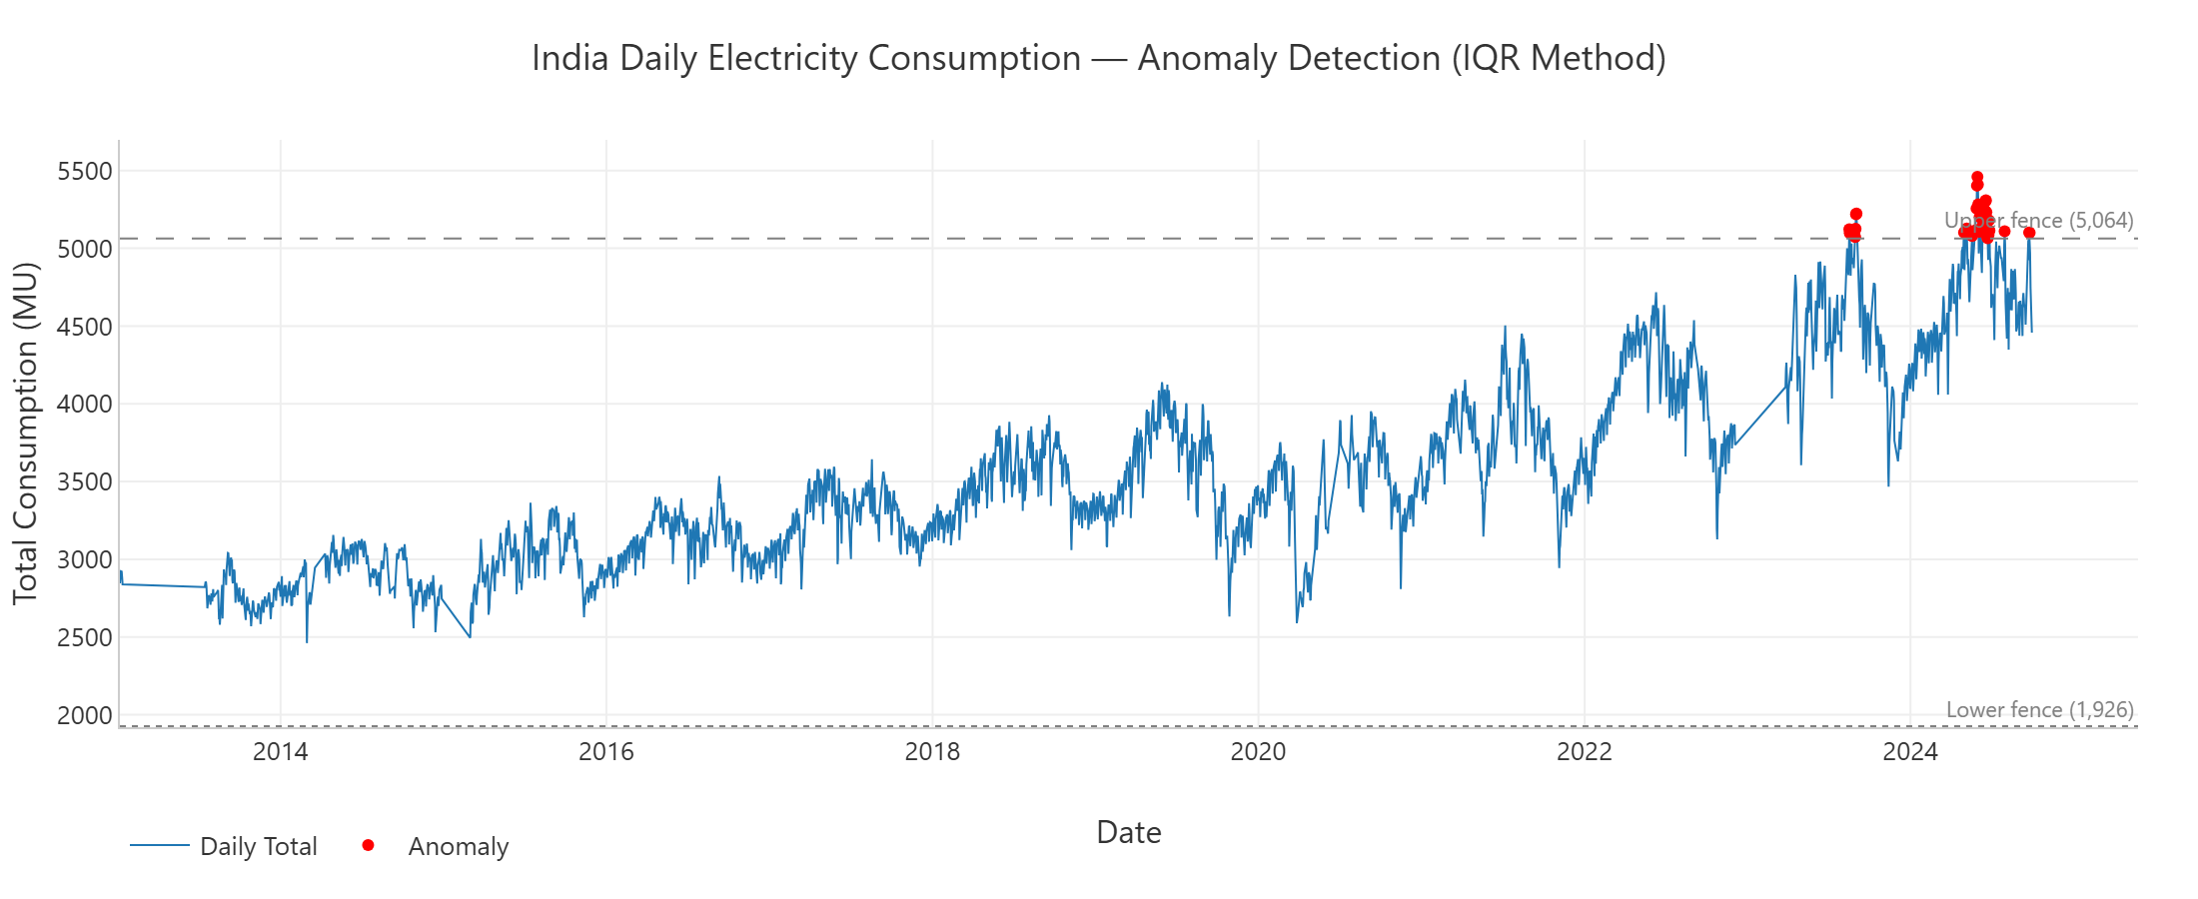
Figure 8 — India Daily Electricity Consumption with IQR Anomaly Detection. Red markers identify the 37 anomalous days. All lie above the upper fence (5,064 MU). IQR fences are shown as dashed reference lines.
National Anomaly Detection Results
Total Labelled Days | 3,707
Anomaly Days Detected | 37 (~1.0% of all records)
Below Lower Fence | 0 (no anomalously low days)
Above Upper Fence | 37
Lower Fence | 1,926.27 MU
Upper Fence | 5,064.08 MU
Anomaly Distribution by Year | 2023: 7 days | 2024: 30 days
Anomaly Distribution by Month | Apr: 1 | May: 8 | Jun: 18 | Jul: 1 | Aug: 5 | Sep: 4

Top 10 Anomalous Days (Highest Consumption)
Date | Total Consumption (MU)
2024-05-30 | 5,460.70
2024-05-31 | 5,409.60
2024-05-29 | 5,403.00
2024-06-18 | 5,309.90
2024-06-17 | 5,303.10
2024-06-01 | 5,283.30
2024-05-28 | 5,255.60
2024-06-15 | 5,246.60
2024-06-19 | 5,233.40
2023-09-02 | 5,224.30

Note: All 37 anomalies are positive spikes above the upper IQR fence. The concentration in 2024 and in the April–September window is observable from the data; however, causal attribution (e.g. heatwaves) is not established within this dataset alone.

11. Forecasting Methodology
Model: Holt-Winters Exponential Smoothing (Triple Exponential Smoothing)
Holt-Winters was selected because the national consumption series exhibits three well-defined components that this model captures explicitly: Level (baseline), Trend (long-term direction), and Seasonality (repeating annual patterns).
Parameter | Value | Rationale
trend | additive | Growth does not accelerate multiplicatively
seasonal | additive | Seasonal amplitude is roughly constant over time
seasonal_periods | 365 | Annual seasonality in daily data
initialization_method | estimated | Fitted from data — more robust than heuristic
optimized | True | Optimizer finds best smoothing parameters
use_brute | True | Grid search for starting values — avoids local minima

Data Pre-processing for Forecasting:
Because 578 calendar dates are absent from the raw dataset, the series is reindexed to a complete daily date range and missing Total Consumption values are linearly interpolated before model fitting. This avoids errors from irregular spacing. Original (non-interpolated) values are used for all other analysis.
Train / Test Split:
Split | Period | Days
Training set | 2013-01-06 → 2024-07-01 | ~4,195 days (≈11.5 years)
Test set | 2024-07-02 → 2024-09-29 | 90 days (held-out)
Forecast | 2024-09-30 → 2024-10-29 | 30 days (future)

12. Forecast Validation Metrics
The model was validated against the held-out 90-day test set (2024-07-02 to 2024-09-29). Three standard forecast accuracy metrics were computed:
MAE (Mean Absolute Error) | 183.01 MU
RMSE (Root Mean Square Error) | 219.93 MU
MAPE (Mean Absolute Percentage Error) | 3.84%
Test Period | 90 days (2024-07-02 → 2024-09-29)

Interpretation: On the held-out test set, the model's daily forecast deviates from actual consumption by an average of 183.01 MU (MAE). The RMSE of 219.93 MU (≈20% above MAE) indicates that large errors are not disproportionately frequent. The MAPE of 3.84% means the model's daily prediction is, on average, within 3.84% of the actual value on the holdout period.

13. Forecast Output
After validation, the model was re-trained on the full dataset (2013-01-06 to 2024-09-29) and used to generate a 30-day forward forecast via forecast_total_consumption(cleaned_df, forecast_days=30).
Forecast Function | forecast_total_consumption(cleaned_df, forecast_days=30)
Forecast Period | 2024-09-30 to 2024-10-29 (30 days)
Uncertainty Band | ±1 RMSE (±219.93 MU) shown around forecast line

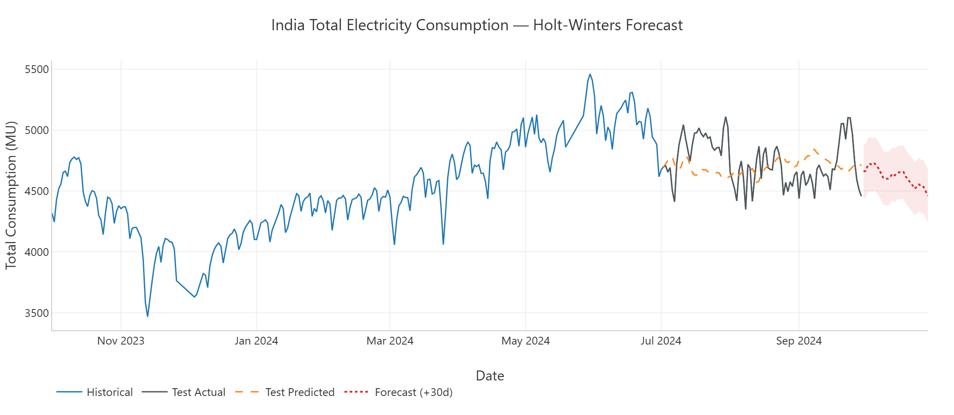
Figure 9 — Holt-Winters Forecast: Historical (blue), Test Actual (grey), Test Predicted (orange dashed), 30-day Forecast (red dotted) with ±1 RMSE band. MAE 183.01 MU | RMSE 219.93 MU | MAPE 3.84%.

14. Interactive Dashboard
The Streamlit dashboard (launched via: streamlit run india_electricity_analysis.py) is the primary end-user interface. It is structured into six sections accessible via sidebar radio navigation:
A. Overview — Four KPI metric cards (Total Consumption, Avg Daily, Peak Day, Lowest Day). National time-series chart with two independent date_input filters (trend_start_date, trend_end_date). Monthly seasonality bar chart. Yearly consumption bar chart with partial-year markers.
B. State Analysis — Sidebar dropdown to select any of the 34 entities. Displays entity KPI cards and a top-N ranked bar chart. Entity yearly trend line chart. Entity monthly seasonality bar chart.
C. Anomaly Detection (National) — Full-width time-series chart with 37 anomalous days highlighted as red scatter markers. Summary metrics panel. Expandable data table of all anomalous dates and values.
D. Anomaly Detection (Entity) — Entity-specific IQR anomaly detection using detect_single_entity_anomalies(). Displays entity-specific fences, anomaly count, and anomaly chart.
E. Forecasting — Cached forecast_total_consumption() with 30-day forward projection. MAE/RMSE/MAPE metric cards. Full forecast chart with ±RMSE uncertainty band. Expandable table of forecast dates and values.
F. Data Quality Report — Auto-generated report: rows, columns, date range, missing values per column, duplicate count, and a summary of all cleaning steps applied. Provides full data provenance transparency.
Dashboard Note: No static screenshot is available in this environment. The dashboard is launched with: streamlit run india_electricity_analysis.py and opens at http://localhost:8501. All six sections above correspond directly to the sidebar navigation labels.

15. Dashboard Design Approach
- Single-file architecture — All 1,500+ lines reside in india_electricity_analysis.py. Streamlit entry point (main()) is called via if __name__ == '__main__'. No additional module dependencies beyond the five listed packages.
- Caching — load_data() and clean_data() are decorated with @st.cache_data. The forecasting function is also cached as it trains a Holt-Winters model on 3,707 rows — without caching this would cause a ~10s delay per interaction.
- Session state for date filters — Both trend_start_date and trend_end_date are initialised once into st.session_state at startup (not on every re-run), preventing the date pickers from resetting when the user interacts with other widgets.
- Plotly for all charts — All visualisations use Plotly Express or Plotly Graph Objects rendered via st.plotly_chart(fig, use_container_width=True). This gives interactive zoom, pan, hover tooltips, and chart PNG export without extra libraries.
- Wide layout — st.set_page_config(layout='wide') is called at the start of main() to maximise chart width.

16. Key Insights
1. Sustained multi-year demand growth. Yearly totals for complete calendar years show consistent increases across the dataset period, consistent with India's industrial expansion and population growth. Partial years (2013*, 2023*, 2024*) are not directly comparable.
2. Strong, recurring seasonal pattern. Monthly analysis reveals higher consumption in the May–August window and in November–January. This pattern is consistent across years and is the primary driver of the Holt-Winters seasonal component.
3. All anomalies are positive spikes — none negative. All 37 anomalous days exceed the upper IQR fence (5,064.08 MU). No day falls below the lower fence (1,926.27 MU). This is observable from the data; the root cause is not established within this dataset.
4. Maharashtra is the dominant consuming entity. It ranks first by total consumption across all years, with values roughly 1.5–2× that of the second-ranked entity (UP). This reflects its large industrial and urban footprint.
5. Holt-Winters achieves a MAPE of 3.84% on the holdout. This means the model's daily forecast was, on average, within 3.84% of actual values over the 90-day test period. RMSE (219.93 MU) being ~20% above MAE (183.01 MU) indicates no extreme individual errors on the test set.
6. Data quality is uneven across entities. Six entities have notable missing values (Pondy 56.1%, Tripura 47.0%). Trends and rankings for these entities should be interpreted cautiously — the missing data is preserved as NaN, not filled.
7. 2020 shows the largest single-year decline. YoY growth of −16.73% in 2020 stands out in the dataset. 2021 shows a corresponding recovery (+23.10%). Causal attribution is not established from consumption data alone.

17. Limitations
- Irregular time series — 578 calendar dates are absent. Holt-Winters assumes evenly spaced observations; missing dates are handled by linear interpolation before fitting, which may smooth out rapid short-term changes.
- Entity-level forecasting not implemented — only national Total Consumption is forecast. State-level forecasting would require separate handling of each entity's missing values and potentially different seasonal profiles.
- No external regressors — the model uses only historical consumption values. Weather, GDP, policy changes, and public holidays are known drivers of electricity demand but are not incorporated.
- IQR anomaly detection is global and univariate — it does not account for seasonal norms. A day above 5,064 MU in summer may be less unusual than the same value in winter. A seasonally-adjusted method (e.g. STL residuals) would be more precise.
- No forecast confidence intervals — the dashboard shows point forecasts with a ±1 RMSE uncertainty band as a visual indicator only, not a statistically derived prediction interval.
- No geographic map visualisation — state-level comparisons are shown as bar charts rather than a choropleth map.

18. Future Improvements
- State-level forecasting — Extend the Holt-Winters pipeline to generate individual 30-day forecasts for each of the 34 geographic entities, with missing-value interpolation applied before model fitting.
- Advanced forecasting models — Compare Holt-Winters against SARIMA, Prophet (Meta), and LSTM on the same 90-day holdout split using identical MAE/RMSE/MAPE metrics.
- Forecast confidence intervals — Add statistically derived 80% and 95% prediction interval bands using Holt-Winters simulation output from statsmodels.
- Seasonally-adjusted anomaly detection — Replace global IQR with STL decomposition residuals (statsmodels.tsa.seasonal.STL) for within-season sensitivity.
- Choropleth map — Add an India state GeoJSON choropleth (Plotly choropleth_mapbox) to visualise entity-level consumption geographically.
- Live data integration — Replace the static CSV with a live POSOCO or National Power Portal API feed to keep the dashboard current beyond September 2024.
- Year-on-year growth rate analysis — Compute and visualise per-entity YoY growth rates to identify fast-growing states relative to their own baselines.

19. Project Structure
Single-file architecture — all code in one Python file. No submodules or helper scripts.
File | Description
india_electricity_analysis.py | All project code (~1,500 lines): loading, cleaning, reshaping, analysis, anomaly, forecasting, charts, dashboard.
Indias_Electricity_Consumption_Dataset.csv | Raw dataset from Kaggle (3,707 rows × 39 cols). Not modified by any project code.
requirements.txt | 5 package dependencies: pandas, numpy, plotly, streamlit, statsmodels.
README.md | Full project documentation: setup, usage, overview, attribution.
YourName_India_Electricity_Analysis_Report_Final.docx | This project report.

Key functions in india_electricity_analysis.py (in order):
Function | Purpose
load_data() | Load raw CSV
clean_data() | Full cleaning pipeline (8 steps)
reshape_for_state_analysis() | Wide → long format melt
calculate_kpis() | National KPIs
calculate_yearly_consumption() | Yearly totals
calculate_yearly_growth() | YoY growth rates
calculate_monthly_consumption() | Monthly totals
calculate_state_consumption() | State totals
calculate_state_statistics() | Per-state descriptive stats
calculate_data_quality_summary() | DQ metrics
calculate_state_kpis() | Per-entity KPI table
calculate_top_entities() | Top-N entities ranking
calculate_entity_yearly_trend() | Entity yearly trend
calculate_entity_monthly_trend() | Entity monthly trend
detect_daily_anomalies() | National IQR anomaly detection
get_anomaly_summary() | Anomaly summary stats
detect_entity_anomalies() | All-entity IQR detection
detect_single_entity_anomalies() | Single-entity IQR detection
forecast_total_consumption() | Holt-Winters forecast
create_time_series_chart() | Plotly daily trend chart
create_monthly_chart() | Plotly monthly chart
create_yearly_chart() | Plotly yearly chart
create_state_chart() | Plotly entity comparison chart
create_anomaly_chart() | Plotly anomaly chart
create_entity_anomaly_chart() | Plotly entity anomaly chart
create_forecast_chart() | Plotly forecast chart
main() | Streamlit dashboard entry point

20. Installation and Execution
Prerequisites: Python 3.8 or higher, pip, the raw CSV in the same directory as the Python file.
- Step 1 — Clone or download the project files into a local directory.
- Step 2 — Install dependencies: pip install -r requirements.txt
- Step 3 — Launch the dashboard: streamlit run india_electricity_analysis.py
- Step 4 — Streamlit opens the dashboard at http://localhost:8501. Use the sidebar to navigate the six sections.
Note: The first load takes approximately 10–15 seconds as the Holt-Winters model trains on 3,707 rows. Subsequent interactions use @st.cache_data and respond immediately.

21. Conclusion
This project demonstrates a complete, end-to-end data analytics workflow applied to a real-world, publicly available dataset of national importance. Starting from a raw CSV with data quality issues, the project delivers cleaned data, multi-level exploratory analysis, statistically grounded anomaly detection, a validated time-series forecast, and an interactive dashboard — all within a single, well-structured Python file.
Key technical achievements:
- A documented, reproducible 8-step cleaning pipeline that handles missing dates, missing entity values, floating-point artefacts, and recalculated aggregates.
- Holt-Winters forecasting achieving MAPE 3.84% on a strict 90-day chronological holdout, confirming that the national consumption series follows a learnable seasonal-trend pattern.
- IQR-based anomaly detection identifying 37 statistically unusual consumption days — all positive spikes — with zero false positives in the lower tail.
- An interactive Streamlit dashboard exposing all analysis layers (overview, entity analysis, anomaly detection, forecasting, data quality) to any user without requiring Python knowledge.
The observed patterns — sustained consumption growth, strong annual seasonality, and concentration of anomalous days in 2024 — are clearly visible in the data and are presented without unsupported causal claims. The project is suitable as a standalone Data Analyst portfolio piece and meets internship evaluation criteria.

22. Data Source and Attribution
Dataset Title | State-wise Electricity Consumption in India
File Name | Indias_Electricity_Consumption_Dataset.csv
Platform | Kaggle
URL | https://www.kaggle.com/datasets/aryankhurana1701/state-wise-electricity-consumption-in-india
Uploaded By | Aryan Khurana (aryankhurana1701)
Underlying Source | POSOCO – Power System Operation Corporation of India
Coverage | 2013-01-06 to 2024-09-29 | Daily | 3,707 observations
Unit | MU (Million Units, equivalent to GWh)
Usage | Educational and portfolio purposes only. Raw CSV not modified.

─────────────────────────────────────────────────────────────────────
End of Report
India Electricity Consumption Analysis & Forecasting | Data Analyst Internship Project | 2024

